OBJECTIVE QUESTIONS

**Q1**. **The data consists of some inconsistent and missing values so ensure that the data used for further analysis is cleaned.**

Answer :

* The Cuisines column had some blank values, which are filled with “blank” to correctly identify them.

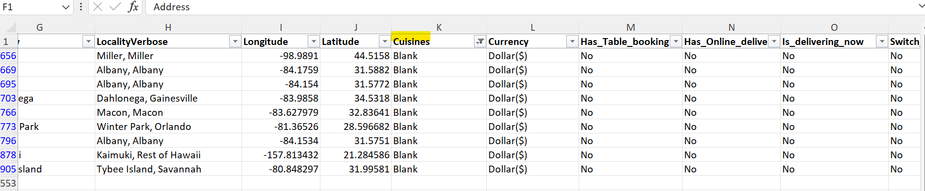

* The **Datekey_Opening** column is split into **Year of opening** , **Month of Opening**, **Day of Opening**

* The **Rating** column is converted into **Rating Buckets** and **Rating Category**

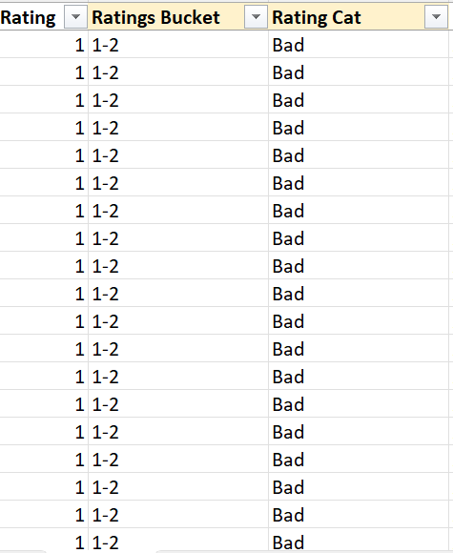

* The Average Cost of Two Column is converted into Average Cost of Two in Dollars to compare the expenditure

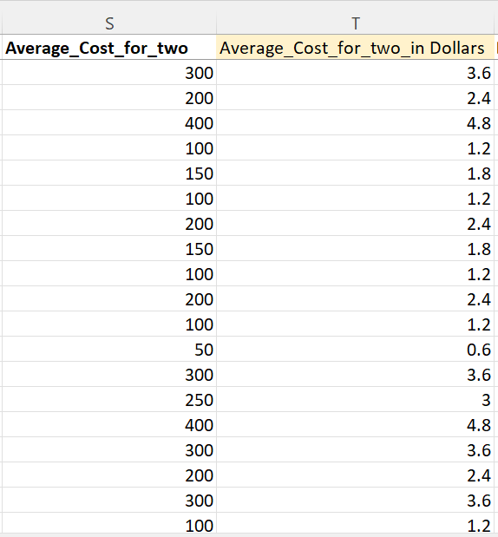

For this, Sheet “Currency Exchange” is used with the current conversion rates of currencies.

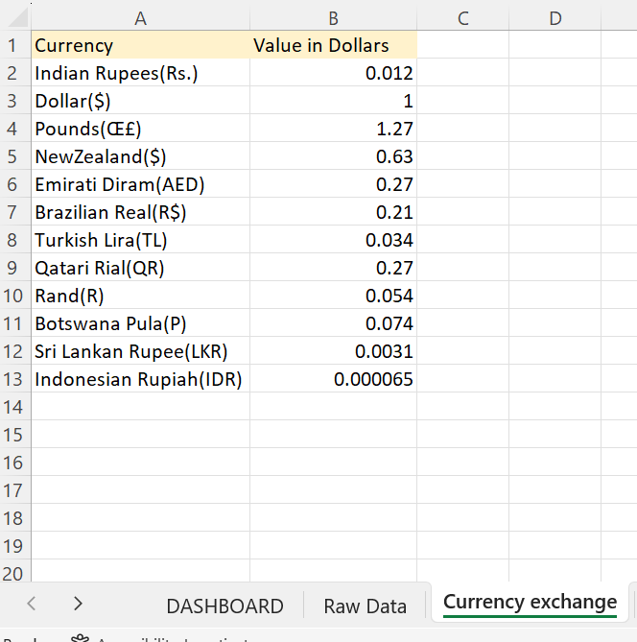

**Q2**. **Using the Look Up functions, fill up the countries in the original data using the country code.**

Answer : Using the Vlookup, the country column is filled

=VLOOKUP(C2,'country description'!$A$1:$B$16,2,0)

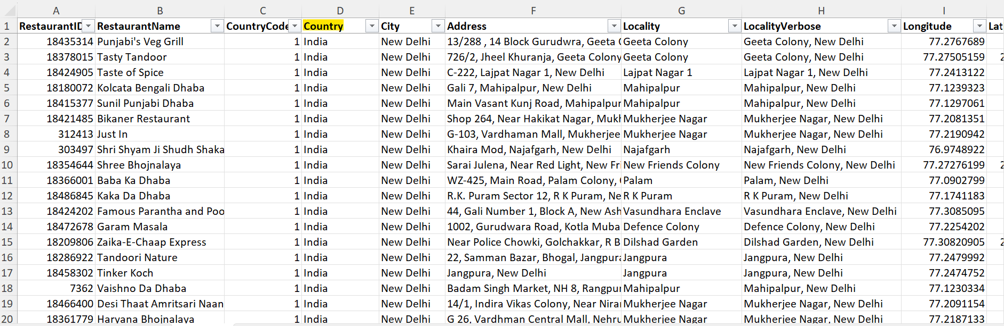

**Q3**.**Create a table to represent the number of restaurants opened in each country**

Answer :

|  |  |
| --- | --- |
| **Country** | **Count of RestaurantID** |
| Australia | 24 |
| Brazil | 60 |
| Canada | 4 |
| India | 8652 |
| Indonesia | 21 |
| New Zealand | 40 |
| Philippines | 22 |
| Qatar | 20 |
| Singapore | 20 |
| South Africa | 60 |
| Sri Lanka | 20 |
| Turkey | 34 |
| United Arab Emirates | 60 |
| United Kingdom | 80 |
| United States of America | 434 |

**Q4.** **Also, the management wants to look at the number of restaurants opened in each year, so provide them with something here.**

Answer:

|  |  |  |  |  |  |  |  |  |  |
| --- | --- | --- | --- | --- | --- | --- | --- | --- | --- |
| **Count of RestaurantID** | **Year of Opening** |  |  |  |  |  |  |  |  |
| **Country** | **2010** | **2011** | **2012** | **2013** | **2014** | **2015** | **2016** | **2017** | **2018** |
| Australia | 4 | 1 | 3 | 6 |  | 4 | 2 | 1 | 3 |
| Brazil | 5 | 12 | 2 | 8 | 11 | 9 | 5 | 4 | 4 |
| Canada |  | 1 |  | 1 |  | 1 |  | 1 |  |
| India | 995 | 995 | 911 | 954 | 946 | 918 | 938 | 992 | 1003 |
| Indonesia | 1 | 5 |  | 1 | 4 | 3 | 1 | 1 | 5 |
| New Zealand | 4 | 6 | 4 | 2 | 4 | 4 | 4 | 5 | 7 |
| Philippines | 6 | 3 | 2 | 1 | 2 | 1 | 1 | 2 | 4 |
| Qatar | 4 | 1 | 2 | 4 | 2 | 2 | 4 |  | 1 |
| Singapore | 2 | 3 | 4 | 1 | 2 | 2 | 1 | 2 | 3 |
| South Africa | 4 | 4 | 7 | 8 | 5 | 7 | 10 | 9 | 6 |
| Sri Lanka | 1 | 2 | 3 | 4 | 2 | 3 | 2 | 2 | 1 |
| Turkey | 3 | 2 | 1 | 5 | 6 | 4 | 4 | 3 | 6 |
| United Arab Emirates | 4 | 3 | 16 | 6 | 9 | 8 | 2 | 6 | 6 |
| United Kingdom | 9 | 6 | 12 | 10 | 11 | 5 | 7 | 12 | 8 |
| United States of America | 38 | 54 | 55 | 50 | 47 | 53 | 46 | 46 | 45 |

**Q5.** **What is the total number of restaurants in India in the price range of 4?**

Answer: Restaurants in India in the price range of 4 = COUNTIFS('Raw Data'!Q:Q,4,'Raw Data'!D:D,"India")

= 388

**Q6. According to the data, what is the average number of voters for the restaurants in each country?**

Answer:

|  |  |
| --- | --- |
| **Country** | **Average of Votes** |
| Australia | 111.42 |
| Brazil | 19.62 |
| Canada | 103.00 |
| India | 137.21 |
| Indonesia | 772.10 |
| New Zealand | 243.03 |
| Philippines | 407.41 |
| Qatar | 163.80 |
| Singapore | 31.90 |
| South Africa | 315.17 |
| Sri Lanka | 146.45 |
| Turkey | 431.47 |
| United Arab Emirates | 493.52 |
| United Kingdom | 205.49 |
| United States of America | 428.22 |

SUBJECTIVE QUESTIONS

**Q1**. **Suggest a few countries where the team can open newer restaurants with lesser competition. Which visualization/technique will you use here to justify the suggestions?**

**Answer :** We will try to find suitable countries to open our new Restaurant on the basis of :

* **Number of Restaurants already present in countries**
* **Expenditure**
* **Ratings of Restaurants**
* According to the below chart, it is clear that INDIA and USA has most number of Restaurants, so we will exclude these as higher number of restaurants will result in more competition.

* According to below chart, we can see that from Canada to Singapore, the Expenditure is quite high. So, keeping in mind the expenditure also, we would further filter out the countries.
* **Turkey**
* **Sri Lanka**
* **Indonesia**
* **South Africa**
* **Australia**
* **Brazil**

According to below chart, we can conclude:

* South Africa, Brazil and Turkey have the most ratings in *Excellent* and *Very Good* Category. This means that people prefer eating in these countries and give better ratings to food

Final countries selected :

1. **South Africa**
2. **Brazil**
3. **Turkey**

**Q2. Come up with the names of States and cities in the suggested countries suitable for opening restaurants.**

**Answer :**

Now as we have selected our countries, its time to look for the cities

We will follow similar approach to drill down to find suitable cities to open new restaurant

We will compare the Count Of Restaurants and Ratings given by customers

With the help of previous 2 charts we can conclude that

* Cities with Highest Count of Restaurants : Sao Paulo , Rio de Janeiro , Brasilia ,Cape Town, Pretoria , Ankara
* Cities with Lowest Count of Restaurants : Randburg, Inner City, Johannesburg
* Now, looking at the ratings, Rio De Janeiro , Ankara , Pretoria, Cape Town stand out High.
* So by considering these 2 factors, we can filter out below suitable cities for our expansion:

1. **Rio De Janeiro**

2. **Ankara**

3**. Pretoria**

**Q3. According to the countries you suggested, what is the current quality regarding ratings for restaurants that are open there?**

Answer : The ratings are clubbed into Rating Brackets as 1-2, 2-3, 3-4, 4-5. Further, these brackets are categorized as :

|  |  |
| --- | --- |
| 1-2 | Bad |
| 2-3 | Good |
| 3-4 | Very Good |
| 4-5 | Excellent |

Now plotting the Ratings for the countries :

From the chart, we can see that most of the ratings are in Excellent and Very Good categories

**Q4. Also, what is the current expenditure on food in the suggested countries, so we can keep our financial expenditure in control?**

Answer : The Average of “Average Cost of Two in Dollars” will give us the expenditure in each country as :

So, Turkey is the Cheapest among the countries we selected

**Q5. Come up with the names of restaurants from the recommended states that are our biggest competitors and also those that are rated in the lower brackets, i.e. 1-2 or 2-3.**

Answer : Biggest competitors will be the Restaurants having rating between 4-5 i.e Excellent.

Below are the lists of competitors for each city suggested :

Restaurants in **Ankara**

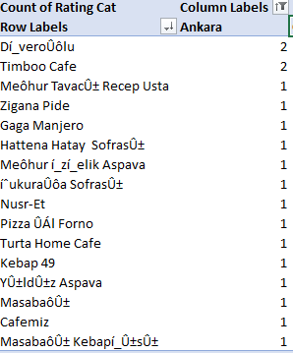

Restaurants in **Pretoria**

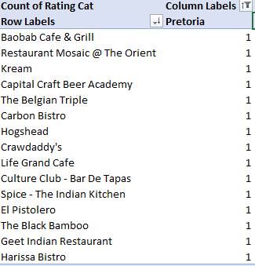

Restaurants in **Rio De Janeiro**

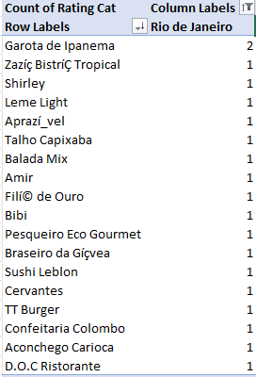

Restaurants rated lower (1-2,2-3) :

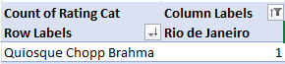

There is only 1 Restaurant “Quiosque Chopp Brahma” rated in lower bracket.

**Q6. Which cuisines should we focus on in the newer restaurants to get better feedback? Does the choice of cuisines affect the restaurant ratings?**

Answer :

* Cuisines are the most important factor need to be considered while opening a Restaurant
* More the popular Cuisines, more it will attract Customers.
* So, we will try to find out, which Cuisines are most popular in these countries.
* We will determine this on the basis of counts of EXCELLENT ratings provided by customers

Below are the cuisines which need to be considered in our new restaurant:

**1.Cafe**

**2.Brazilian**

**3.Brazilian Bar Food**

**4.Italian**

**5.Kebab,Turkish Pizza**

**Q7**. **According to our current data, should we go for online delivery and table booking? Does that affect the customer’s ratings?**

Answer: **Online Table Booking** :-

* In this era of Online World, it is crucial to keep Online options available for the customers
* Customers would be happier if they could book a table just by sitting at home.
* Lets see the general trend of Online Table Booking in our selected countries.
* According to the chart, we can see that most of the restaurants DO NOT provide the Online Table Booking option
* So if we introduce this feature in our new restaurant , then its more likely to attract more customers

**Online Delivery**:-

* Online Delivery is also one of the major factors in increasing the revenue of a restaurant
* Online Delivery helps restaurants to increase their reach and number of customers
* We will see how much restaurants are providing this facility in our selected countries
* According to the chart, we can see that **NONE** of the restaurants provide Online Delivery
* So, it would be really beneficial for our restaurant if we can provide Online Delivery facility in these countries.

**Q8. Should the team keep the rate of cuisines higher? Will that affect the feedback? According to our data are the rates of cuisines and ratings, correlated?**

Answer : The plot between Price Range of cuisines and Rating is below :

* We have compared Excellent Rating with our Price Range Of Cuisines and found that most of the Excellent Ratings fall under Price Range of 3 and 4
* This indicates that we can have Price Range High in our restaurants

Measuring the correlation between Price Range and Rating :

=CORREL('Raw Data'!Q:Q,'Raw Data'!U:U)

= 0.46

So, both are **Moderately Correlated**.

**Q9.What is the distribution of number of restaurants of different price ranges in all the countries?**

**Answer :** Below are the table and chart showing the distribution of No. of restaurants of different price range across all the countries.

|  |  |  |  |  |  |
| --- | --- | --- | --- | --- | --- |
| **Count of RestaurantID** | **Column Labels** |  |  |  |  |
| **Row Labels** | **1** | **2** | **3** | **4** | **Grand Total** |
| Australia | 4 | 14 | 5 | 1 | 24 |
| Brazil | 2 | 7 | 16 | 35 | 60 |
| Canada |  | 3 |  | 1 | 4 |
| India | 4295 | 2858 | 1111 | 388 | 8652 |
| Indonesia |  | 1 | 20 |  | 21 |
| New Zealand | 3 | 4 | 17 | 16 | 40 |
| Philippines |  | 1 | 12 | 9 | 22 |
| Qatar |  | 1 | 5 | 14 | 20 |
| Singapore |  | 1 | 5 | 14 | 20 |
| South Africa |  | 4 | 17 | 39 | 60 |
| Sri Lanka |  | 6 | 11 | 3 | 20 |
| Turkey |  | 11 | 18 | 5 | 34 |
| United Arab Emirates |  | 9 | 29 | 22 | 60 |
| United Kingdom | 4 | 28 | 32 | 16 | 80 |
| United States of America | 136 | 165 | 110 | 23 | 434 |
| **Grand Total** | **4444** | **3113** | **1408** | **586** | **9551** |